ASSIGNEMENT 3

LESSONS LEARNED

* HOW TO USED J UNIT TO TEST ANY CASE
* HOW TO COMPARE 2 STRING
* HOW TO USE GFA TEST
* But I have a big issue when it come to GUI, I really need help to solve that because I am not able to figure it out

JUNIT TEST SCREENSHOT

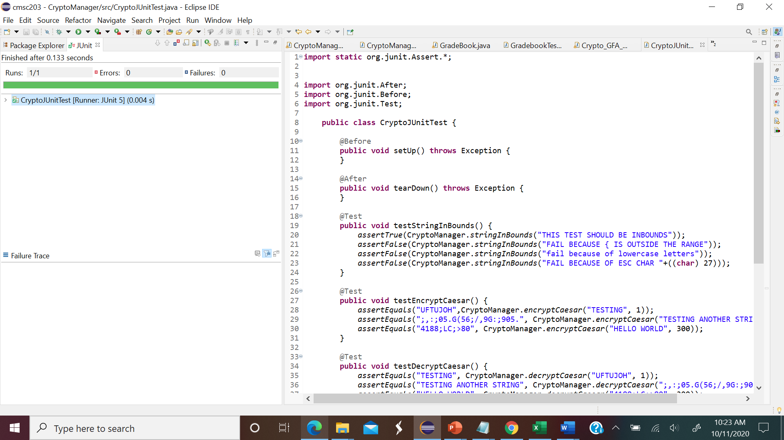

GFA TEST SCREENSHOT

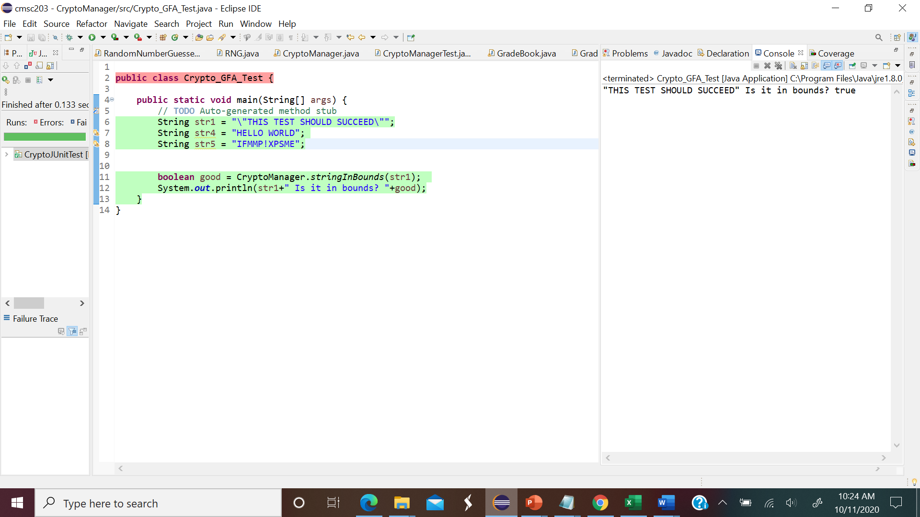

CRYPTO MANAGER TEST SCREEN SHOT

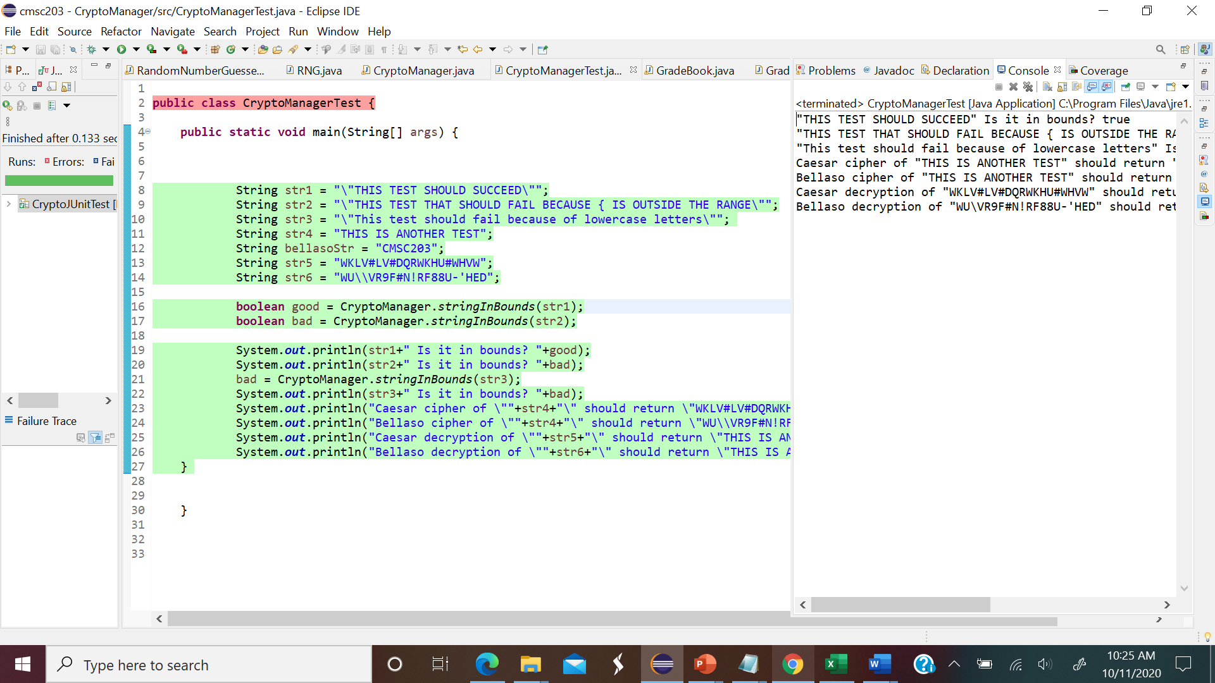

TEST PLAN

Test your program with at least 3 test cases. **Make sure your tests cover all the possible scenarios.**

|  |  |  |  |  |  |
| --- | --- | --- | --- | --- | --- |
| Input text | Input Key | Encrypted (method1) | Encrypted (method2) | Decrypt (method1) | Decrypt (method2) |
| TESTING ANOTHER STRING | 999 | "MERRY CHRISTMAS", "CMSC207" | "HELLO WORLD", 300) | "UFTUJOH", 1 | "UJ^^((HT^X[YYM\"", "HELLO" |
| "TESTING", 1 | 1 | TESTING" | TESTING", "CIPHER_IS_LONGER_THAN_THE_PLAIN_TEXT | ("UFTUJOH", 1 | WN#\\N &", "CIPHER_IS_LONGER_THAN_THE_PLAIN_TEXT |
|  |  |  |  |  |  |
|  |  |  |  |  |  |

**Grading Rubric**

See attachment: CMSC203 Assignment 3 Rubric.xlsx

Assignment 3 Check List

|  |  |  |  |
| --- | --- | --- | --- |
| **#** |  | **Y/N** | **Comments** |
|  | **Assignment files:** |  |  |
|  | * FirstInitialLastName_ Assignment#_Moss.zip | **<Yes or No>** | **YES** |
|  | * FirstInitialLastName_Assignment#.docx/.pdf | **<Yes or No>** | **YES** |
|  | * Source java files | **<Yes or No>** | **YES** |
|  | **Program compiles** | **<Yes or No>** | **YES** |
|  | **Program runs with desired outputs related to a Test Plan** | **<Yes or No>** | **YES** |
|  | **Documentation file:** |  |  |
|  | * Comprehensive Test Plan | **<Yes or No>** | **YES** |
|  | * Screenshots for each Test case listed in the Test Plan | **<Yes or No>** | **YES** |
|  | * Screenshots of your GitHub account with submitted Assignment# (if required) | **<Yes or No or N/A>** | **NO** |
|  | * UML Diagram (if required) | **<Yes or No or N/A>** | **NO** |
|  | * Algorithms/Pseudocode (if required) | **<Yes or No or N/A>** | **YES** |
|  | * Flowchart (if required) | **<Yes or No or N/A>** | **NO** |
|  | * Lessons Learned | **<Yes or No>** | **YES** |
|  | * Checklist is completed and included in the Documentation | **<Yes or No>** | YES |